**Flowchart**

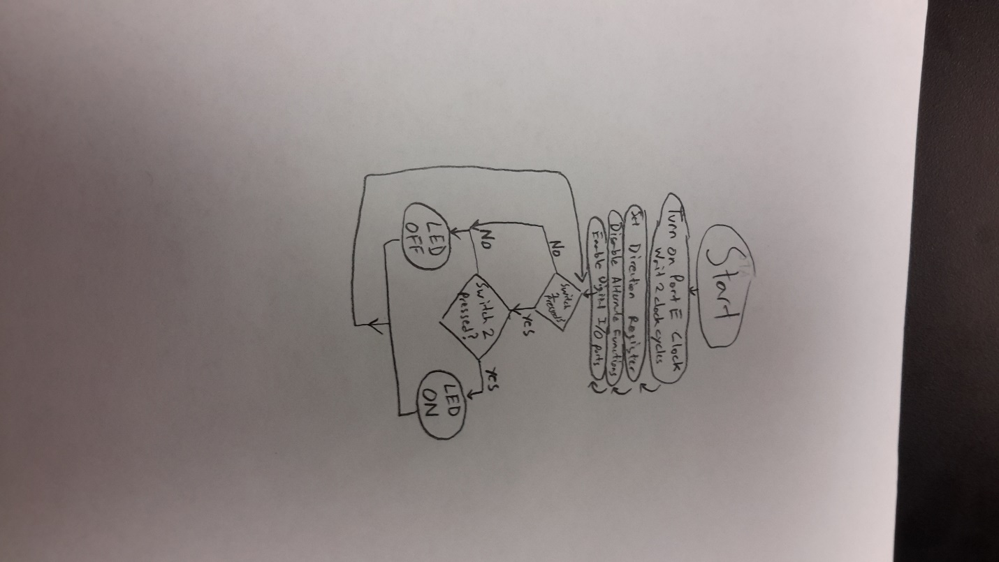

**Pseudo Code**

Turn on Port E Clock and wait 2 clock cycles

Set Direction Register (output PE2, input: PE3, PE4) 1=output 0=input

Disable Alternate Functions of Registers

Enable Digital I/o Port

Loop Get PORTE DATA

Test if PE3 is 0, else Branch to turnoff

Test if PE4 is 0, else Branch to turnoff

Turn ON PE2

Branch to Loop

TurnOff Turn off PE2

Branch to Loop

**Main.S Program**

;****************** main.s ***************

; Program written by: Kyle Sikora and Briar Coker

; Date Created: 1/24/2015

; Last Modified: 1/24/2015

; Section 1-2pm TA: Wooseok Lee

; Lab number: 1

; Brief description of the program

; The overall objective of this system is a digital lock

; Hardware connections

; PE3 is switch input (1 means switch is not pressed, 0 means switch is pressed)

; PE4 is switch input (1 means switch is not pressed, 0 means switch is pressed)

; PE2 is LED output (0 means door is locked, 1 means door is unlocked)

; The specific operation of this system is to

; unlock if both switches are pressed

GPIO_PORTE_DATA_R EQU 0x400243FC

GPIO_PORTE_DIR_R EQU 0x40024400

GPIO_PORTE_AFSEL_R EQU 0x40024420

GPIO_PORTE_DEN_R EQU 0x4002451C

GPIO_PORTE_AMSEL_R EQU 0x40024528

GPIO_PORTE_PCTL_R EQU 0x4002452C

SYSCTL_RCGCGPIO_R EQU 0x400FE608

SYSCTL_RCGC2_R EQU 0x400FE108

AREA |.text|, CODE, READONLY, ALIGN=2

THUMB

EXPORT Start

Start

;PE2 = 0 off, 1 ON

;PE3 = input switch = 1 notpress, 0 pressed

;PE4 = input switch = 1 notpress, 0 pressed

;PE2 = 1 if and only if PE3 = 0 && PE4 = 0

;Turn on Port E Clock and wait 2 clock cycles

LDR R1,= SYSCTL_RCGCGPIO_R

LDR R0,[R1]

ORR R0,R0,#0x10

STR R0,[R1]

NOP

NOP

;Set Direction Register (output PE2, input: PE3, PE4) 1=output 0=input

LDR R1,=GPIO_PORTE_DIR_R

LDR R0,[R1]

ORR R0,#0x04

BIC R0,#0x18

STR R0,[R1]

;Disable Alternate Functions of Registers

LDR R1,= GPIO_PORTE_AFSEL_R

LDR R0, [R1]

BIC R0,#0x1C

STR R0,[R1]

;Enable Digital I/o Port

LDR R1,=GPIO_PORTE_DEN_R

LDR R0,[R1]

ORR R0,#0x1C

STR R0,[R1]

;R1 = PORTE data address location

LDR R1,=GPIO_PORTE_DATA_R

loop

;Get PORTE DATA

LDR R0,[R1]

;Test if PE3 is 0, else Branch to loop

MOV R3,R0

AND R3,#0x08

CMP R3,#0x00

BNE TurnOff

;Test if PE4 is 0, else Branch to loop

MOV R4,R0

AND R4,#0x10

CMP R4,#0x00

BNE TurnOff

;Else Turn ON PE2

ORR R0,#0x04

STR R0,[R1]

B loop

TurnOff

BIC R0,#0x04

STR R0,[R1]

B loop

ALIGN ; make sure the end of this section is aligned

END ; end of file

**Screenshot of Picture**

